Lecture 3: Other response analysis tools
Approaches to Market Analysis
- Emergency Market Mapping and Analysis Tool (EMMA)
- World Food Programme Emergency Food Security Assessments (EFSAs)
- FEWS NET Market Assessment and Analysis
- Tradeoffs

Readings
- Donovan, Cynthia and Megan McGlinchy. 2006. “Market Profiles and Emergency Needs Assessments: A summary of methodological challenges.” May. World Food Programme, Emergency Needs Assessment Branch (ODAN). http://documents.wfp.org/stellent/groups/public/documents/ena/wfp095655.pdf

Supplementary Readings
- WFP, “Emergency Food Security Assessments Technical Guidance Sheet 2: Integrating non-food responses to food insecurity into emergency food security assessments (EFSAs) http://documents.wfp.org/stellent/groups/public/documents/manual_guide_proced/wfp197292.pdf
- Selections from Albu, M. (2009) EMMA Implementation Guidelines. “Introduction and Overview.” http://practicalaction.org/docs/emma/EMMA-introduction-and-overview.pdf
- Selections from World Food Program (2009) Emergency Food Security Assessment Handbook. Chapter 5 pp. 193-208. http://documents.wfp.org/stellent/groups/public/documents/manual_guide_proced/wfp203245.pdf
- FAO, 2006. “Briefing Note: The IPC.” http://www.ipcinfo.org/attachments/esaf_pb_issue3_IPC.pdf
- FEWs Net (2008) “Market Assessment and Analysis: Learners Notes. Lesson 2: Assessing Markets: Annex 12 & 13” FAO. pp. 39-43. http://www.fews.net/docs/Publications/Market%20Assessment%20and%20Analysis%20Training%20Module.pdf

Introduction to approaches to market analysis
This lecture examines several different approaches to market analysis in addition to MIFIRA, which was described in lecture 2. We briefly review Oxfam’s EMMA, WFP-EFSA / CSFVA, and FEWS-Market Assessment and Analysis. There are other approaches (not necessarily response analyses) that generate market information as well, including market assessment guidelines of the International Committee of the Red Cross, Sphere Project on Minimum Standards for Economic Recovery, the FAO Integrated Phase Classification System and USAID Bellmon analysis. There is substantial overlap, parallels, and cross-pollination among the approaches. However, each approach has slightly different objectives, methods, duration of assessments, users, and (sometimes) audiences. These differences highlight the varying suitability of different approaches in different contexts, and can serve to clarify MIFIRA’s particular approach.

While the approaches, objectives, or users may differ, the analytical tools underpinning each approach are quite similar. All frameworks require preliminary analysis of available secondary data. Most use key informants for contextualizing information as well. WFP’s response analysis is combined with other baseline data collection for needs assessments and targeting options, while FEWS NET’s response analysis is combined with other market-based data collection.

EMMA
- Objective
  - By better understanding the effects of an emergency on the most critical market systems, agencies can (1) more efficiently direct humanitarian resources, (2) decrease dependency on outside resources, and (3) encourage transitions to economic recovery
- Approach
  - One-time rapid assessment (usually lasting less than 3 weeks)
  - Follows an emergency, once the situation has begun to stabilize
  - Considers any market system deemed critical (including food markets, non-food markets, and services markets)
  - Can also make recommendations on indirect responses (i.e., market-system support, such as infrastructure, grants to re-establish markets, etc.)
- Users
  - Developed by Practical Action and commissioned by Oxfam, IRC and InterAction
  - Teams of local NGO staff, knowledgeable about local environs
  - Limited prior economic knowledge required
- Audience
  - Decision-makers responsible for planning recovery programming
- Methodological approach: market-system mapping
  - First, identify which market systems are of interest. Examples: lumber (for housing); local procurement of pulses; fishing materials
    - Identifying the most relevant market-systems can be difficult
    - Requires coordination with other agencies that may be supporting components of the market system or may be bypassing that system (e.g., distributing free roofing materials)
    - Some market systems are complementary, and analyzing individual systems in isolation is difficult. For example, considering lumber without also considering roofing materials, nails, hammers, etc. will give an incomplete picture.
  - Develop a market map that reflects marketing environment pre- and post-crisis.
    - Sketch out market actors and linkages; infrastructure; institutions
    - Consider seasonality, competition, and market integration
    - Add quantities and prices (both pre-crisis and post-crisis)
    - Identify constraints to demand and supply and possible bottlenecks
    - Forecast system responsiveness based on available options
  - Intentionally a predominantly qualitative approach, given the short duration of assessment and rapidity of change following a crisis
  - Response analysis component, presents a series of questions about transfer options, answerable by following the EMMA steps

EMMA Market System Map (2008 Beans Procurement in Haiti)

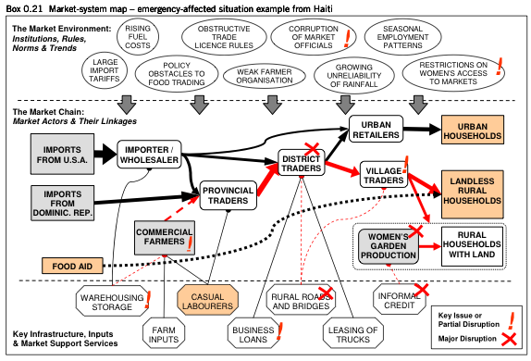
Source: Albu 2010.

EMMA’s market system map informs the below response analysis framework by identifying whether the market system worked well before the emergency and whether the constraints it now faces can be resolved. For example, in the above case, agencies may choose to support village traders and provide relief until district traders recovers.

EMMA: Response Analysis: Supply Market Systems
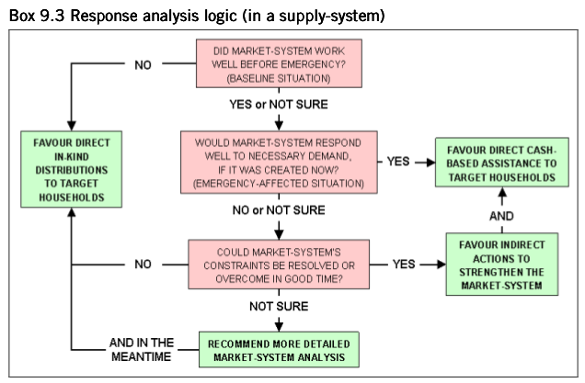
Source: Albu 2010.

Note that some of these questions are quite similar to the MIFIRA questions.

WFP – Emergency Food Security Assessment (EFSA)
- Objective
  - The EFSA is complementary to the comprehensive food security vulnerability analysis (CFSVA).
  - The objective of the CSVA is to describe the food security status of various populations across a region, analyze the causes of the vulnerability, and recommend appropriate interventions.
  - The EFSA is “intended for use in emergency situations or protracted crises, whether due to sudden natural disaster, drought, disease, economic collapse or conflict, and to address the needs of both resident and displaced persons” (WFP EFSA p. 12).
- Approach
  - The CSFVA requires in-depth data collection and analysis, requiring 4-8 months and numerous staff. The intent of the CSFVA is to compile statistically significant samples so that a variety of indicators can be generated for populations at risk of food insecurity.
  - Crisis-prone food insecure countries are targeted for CFSVAs, ideally, creating a baseline platform for any follow-on EFSAs.
  - There are three types of EFSA: initial, rapid, and in-depth, with increasing time and methodological demands. Response analysis is one aspect of the EFSA emergency assessments.
  - The EFSA response analysis outputs include:
    - Identification of the risk factors;
    - Identification of the broad sectors and types of intervention required – the entry points;
    - Review of the intervention plans and capacities of government and other actors, and identification of gaps in these;
    - Identification of a range of response options to fill the gaps, and the strengths, weaknesses, opportunities and threats (SWOT) associated with each;
    - Selection of the most appropriate response option(s);
    - Recommendations for interventions, including targeting criteria, timing, scale and duration.
- Users
  - Technical staff and field staff
  - The more in-depth the EFSA, the greater the need for technical capacity.
- Audience
  - WFP decision-makers, donors and media
- Methodological approach
  - Work through Decision Tree for Response Options
  - Compile a SWOT analysis (strengths, weaknesses, opportunities, and threats)
    - Strengths and weakness (i.e., appropriateness) of the options
      - Compatibility with needs
      - Stigmatizes recipients, diverts them from other tasks
      - Feasibility
        - Realistic targeting
        - Timeliness of response
    - Opportunities and threats that may affect the response
      - E.g., improving / deteriorating security
  - Rank and prioritize the response options, and consider whether responses should be combined into one program.
  - Targeting recommendations are also made as a component of response analysis.

WFP Emergency Food Security Assessment Response Analysis (2009, Chapter 4, p. 203).
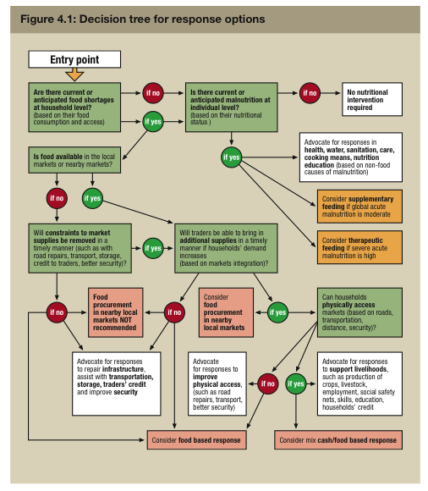
Source: World Food Program 2009.

FEWS NET Market Assessment and Analysis
- Objective
  - FEWS NET materials provide training in markets and food security. Additionally, FEWS NET presents some for cash versus food response analysis questions to consider (Lesson 3, Appendices 12 and 13).
- Approach
  - Developed by FEWS NET for FAO as a publicly available, on-line training course
  - Provides a series of lessons about: the relationship between food security and markets; assessing markets; and using and interpreting market indicators
- Users
  - FAO staff and others. Potentially informing on-going reporting undertaken by FEWS NET staff
- Audience
  - Capacity building course for individuals using food security information in decision-making
- Methodological approach
  - Series of response analysis questions are similar to the WFP’s decision tree for response options
  - No explicit linkages between questions and tools necessary to answer such questions.

FEWS NET: Market Assessment and Analysis: Annex 12: Typical Markets Questions for Cash vs. Food Response Choices (Lesson 2, p. 39)

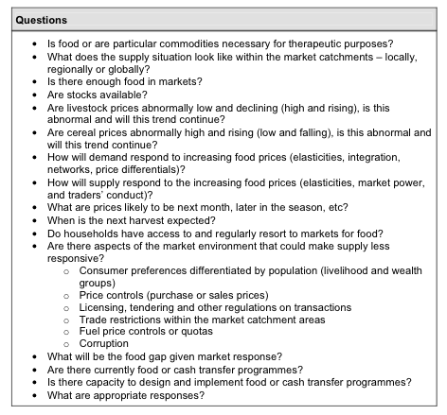

Other tools and resources:
The above review is not exhaustive. There are many other important needs assessment and response analysis tools.

For example, the livestock emergency guidelines and standards (LEGS) is a response analysis approach intended to assist analysts and donors in the design and implementation of livestock interventions in emergencies. See http://www.livestock-emergency.net/ for more information.

The integrated food security phase classification tool (IPC) compiles data from numerous sources to provide a common scale and a standardized approach to food security needs assessment. See http://www.ipcinfo.org/ for more information.

Tradeoffs and choices across approaches:
- Objectives: Components of a response analysis
  - Many NGOs have programming objectives that will guide how response analysis findings are transformed into programs. These programming choices (e.g., form of targeting, and frequency, size, and location of transfers) will affect the suitability of different forms of responses. Smart programming can help to mitigate possible negative effects of various choices.
  - While it may recommend particular programming options, MIFIRA is not a program design tool. Other approaches bundle response analysis and program design or needs assessment. For example, WFP’s response analysis also includes recommendations on targeting types, which MIFIRA treats as a program design choice.
- Objectives: Range of interventions
  - EMMA’s response analysis includes structural changes (e.g., rebuilding infrastructure, changing trade policy).
  - MIFIRA’s response analysis identifies appropriate transfers for food security programming.
- Approach: Data requirements (e.g., reliance on baselines and/or primary data)
  - EMMA is intended to be implemented in areas without baselines.
  - The other approaches more explicitly tap into existing secondary data and desire baseline analyses in areas that face recurring food insecurity. For example, MIFIRA baselines could be components of disaster preparedness plans.
- Approach: Duration of the assessment
  - Within each approach, the duration varies based on the availability of baselines, the type of crisis, and the potential for drastic changes to the market system. The duration will also vary by the need for rapid response or for defensibility of findings.
- User capacity
  - Capacity requirements can be broken roughly into two types: field (contextual) expertise and technical (analytic) expertise.
  - In MIFIRA, these two types of expertise are complementary. Contextual knowledge can help identify potential focal areas of analysis. Analytic knowledge can synthesize competing views or conflicting information.

MIFIRA is not a mechanical formula to be implemented identically in all places and times. MIFIRA offers a carefully and logically structured set of questions backed up by methods of feasibly yet rigorously answering those questions. The linking of these questions to analytic methods is one way in which MIFIRA adds value.

